Boomerang's Pet Foodbank Volunteer Application Form

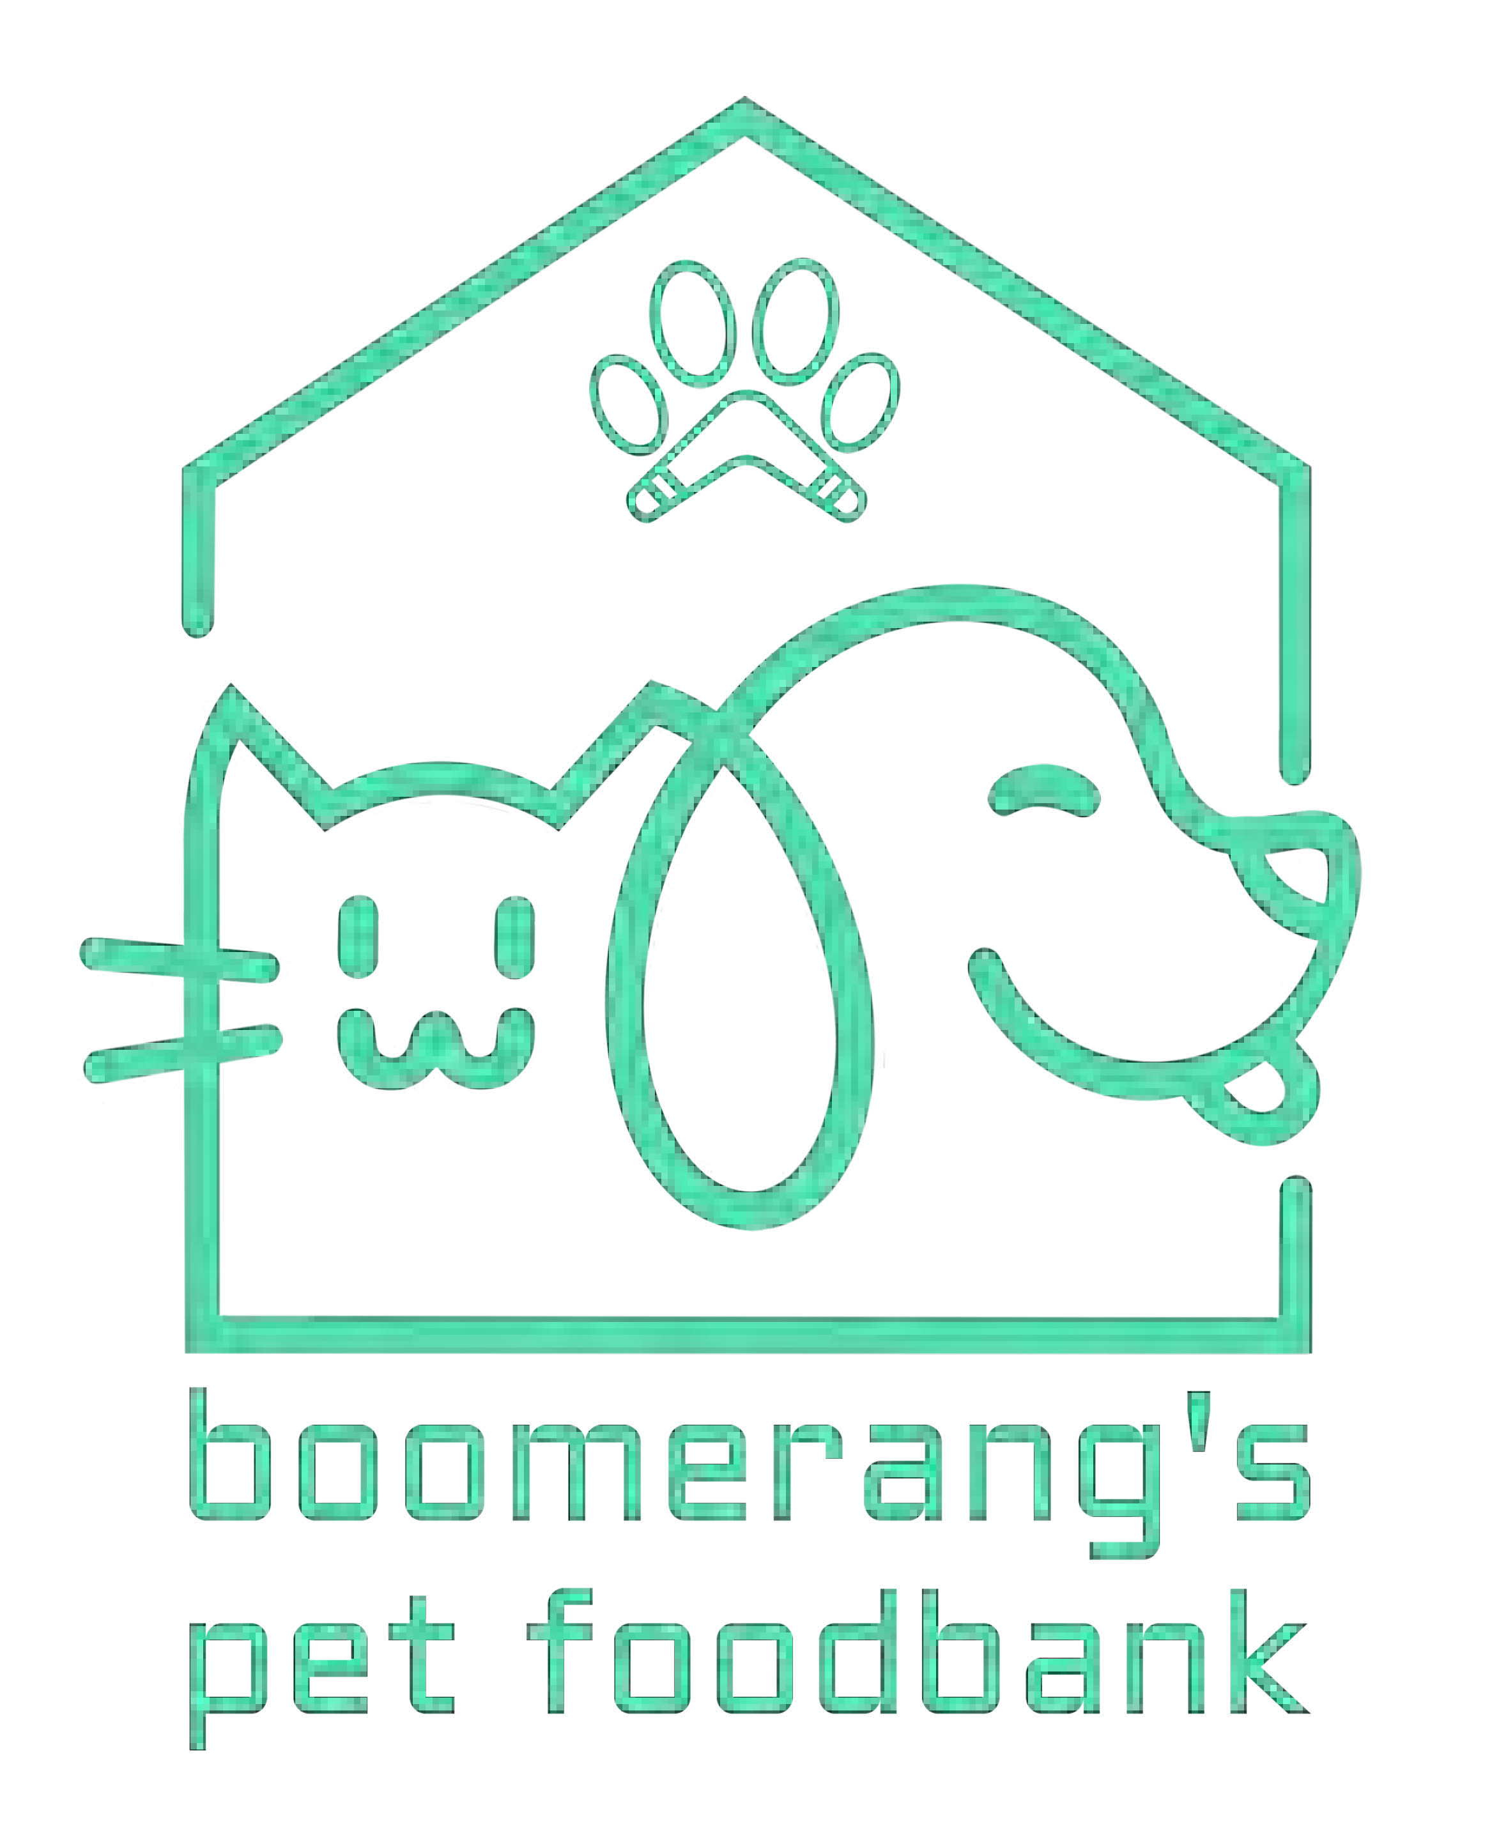
Charity No: 1200695

Title: | First name: | Surname:
Address: |  | Email:
 |  | Landline:
 |  | Mobile:
 |  | Are you over 18: Yes / No
Please indicate the area(s) of volunteering work you would like to undertake:
Fundraising Warehouse - sorting stock
Administration Stock collection/delivery (driving)
Publicity/Social Media Event organisation
Other suggestions:
If you are volunteering to drive, do you hold a full driving licence: Yes / No
*If yes please provide details of any endorsements
Skills, experience and Interests:
Please give details of any relevant skills, experience and interests, that you would bring to the charity.

Availability:
Please provide details of your availability for volunteering. Example - Day/s, AM/PM
Criminal Convictions:
If you have any criminal convictions (except those ‘spent’ under the Rehabilitation of Offenders Act) please give details:

Medical needs:
Please provide any information regarding medical needs that you wish to disclose that may affect your volunteering:
* Lifting and carrying are a key part of the warehouse and driving roles.

Referees:
Any offer of volunteering is dependent on receipt of satisfactory references. Please provide details of two
referees who can comment on your suitability for this voluntary role. These should be someone other than a close relative.

Referee 1: Referee 2:
Name: | Name:
In what capacity does this person know you,  professional or personal? | In what capacity does this person know you,  professional or personal?
Organisation (if applicable): | Organisation (if applicable):
Tel: | Tel:
Email: | Email:
How did you hear about volunteering opportunities at Boomerang’s Pet Foodbank:

Declaration and signature:
I confirm that the information contained in this application form is accurate and correct.

Signature Date
Boomerang's Pet Foodbank promises to respect and keep safe any personal data you share with us and comply with the General Data Protection Regulation regarding gathering, storing, sharing and deletion of personal data.

Thank you for your interest in volunteering for Boomerang’s Pet Foodbank
Please return this form to Info@boomerangspetfoodbank.co.uk

